There were a number of limitations that should be considered when interpreting the results. MR, U/S, and histopathology differed in their ability to accurately capture the entire prostate. The intrinsic differences in their ability to capture the entire prostate were difficult to quantify. It is known that pathology reconstructed capsule volumes had their far apex and base prostatic components removed, leaving only the thicker middle portion of the prostate (citation?). In MR, certain prostates clearly had part of their apex missing, and transrectal MR probe compression may have slightly expanded lateral MR prostate lengths while shrinking elevation MR prostate lengths (image evidence or some type of proof?). This effect was exaggerated in ARFI prostates due to the increased U/S transrectal probe curvature relative to MR. All these effects were dependent on prostate size, variable transrectal probe compression, and transrectal probe orientation relative to the prostate (citation?). The missed parts of the prostate along the apex-to-base length in MR and pathology may have altered true prostate volumes, and lead to apex-to-base length underestimation relative to ARFI. Expansion of the lateral prostate length, and compression of elevation prostate length due to MR and U/S transrectal probe compression altered lateral and elevation tri-axial length, but did not change prostate volume. (awaiting results to make some sort of final statement on this, I think the above may account for the volume divergence in the minority of prostates).
Another limitation, although more aesthetic than quantitative due to small volume variation, was the heavy reliance on segmenter discretion and experience in the sagittal U/S segmentations. This was a result of the difficulty resolving certain parts of the prostate from surrounding tissue. The seminal vesicles in the left and right posterior prostate base-mid gland run continuously into prostatic tissue, and their acoustic and stiffness properties differ little from surrounding tissue. Thus the sole guide for segmentation in this region was anatomical location. Segmentations started in the anterior base of the prostate, and used the bladder as a marker. These segmentations then proceeded posteriorly towards a space that separated prostate from seminal vesicle immediately before seminal vesicle became continuous with the prostatic tissue. From this space, the segmentation used a smooth curve that ran through seminal vesicle tissue, and terminated mid-gland in the peripheral zone.
Base
a.
b.
c.
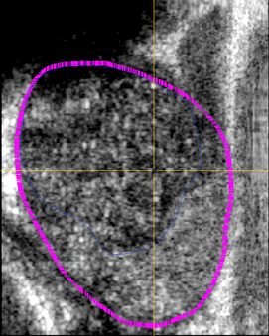

d.

f.

e.
Anterior
Posterior

g.
h.
i

Apex

Figure X: Capsule (pink) and CG (blue) sagittal segmentations demonstrating difficulty resolving prostate from surrounding tissue. Anatomic Image Labels are also shown.

It is entirely possible that either seminal vesicle was included in the segmentation when it should not have been, or that peripheral zone was missed by this segmentation technique. From the axial images toward the base, it appeared that the seminal vesicles were not included, but a small amount of peripheral zone was consistently missed in these segmentations.
Anterior

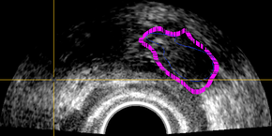

c.

Right
g.
Left

a.

h.

Posterior

Figure X: Missed Peripheral zone (red) as a result of oversegmenting seminal vesicle on axial image. Capsule (pink) and CG (blue) are also shown along with anatomic image labels

Full inclusion of the seminal vesicles in the segmentation relative to the method described above resulted in volume differences of 9-26%. Repeated segmentations using the technique described above resulted in volume differences of 1-3%. There were no significant variations in tri-axial dimensions. These results suggest that the technique as described resulted in fairly accurate prostate volumes fluctuating about some true mean. An additional source of segmentation error was the difficulty resolving prostate from surrounding tissue in the far left and right sagittal planes. Unsurprisingly, both axial and coronal label slice intersections demonstrated slight underestimations of prostate lateral extent.
Anterior

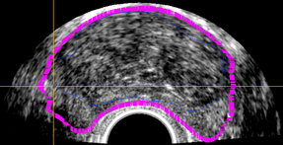

e.
Right
Left

g.
h.
Posterior

Figure X: Axial Image showing missed right and left lateral components (red). Capsule (pink) and CG (blue) are also displayed along with anatomic image labels

Table X: Corresponding Descriptions of Label Letters from Figure X

Label Letters | Description
a. | Seminal Vesicle at left-posterior-base
b. | Space/separation between bladder and seminal vesicle at which point the smooth curve is drawn towards posterior-mid apex-to-base gland
c. | Bladder
d. | Bladder neck
e. | Central Gland
f. | Different slopes of smooth curves that could be reasonably used to segment out the central glands. These different curves result in volume changes of 1-3%.
g. | Peripheral Zone
h. | Rectal Wall anterior to probe face
i | Fibromuscular tissue

Similar to the problem of resolving seminal vesicles, capturing the left and right lateral ends of the prostate was a question of aesthetics, not volume as percent volume differences for prostates with greater lateral extent segmented were less than 1%.
The need to downsample the U/S prostate volumes, although necessary for time saving, further complicated the sagittal segmentation. Without downsampling, the difficulties seen in the sagittal segmentation ie missing far lateral prostate components and peripheral gland at the base anterior to the seminal vesicles could easily have been corrected by segmenting on the axial and coronal planes. Image downsampling, however, resulted in label segmentations in the axial and coronal planes made of 3 mm blocks. These block-like label segmentations allowed only coarse changes in the axial and coronal planes. On average though, segmenting both the downsampled U/S capsule and CG took forty five minutes. Segmentation times beyond this time period for a data set this size would be inefficient, and not worth the minor improvements in accuracy.

